 

INFRASTRUCTURE APPLICATION REQUIREMENTS -  
*SONAR*

Version: 1.2

Date: *21-12-2023*

Based on Template: UWV REQ – TEMPLATE 2.0docx

Table of Contents

Table of Contents 2

Document purpose: 3

Relation to other documents 4

Content of the document 4

Document change history 4

1 Application Overview 5

1.1 Introduction 5

1.2 Scope of the desired change 6

1.3 Application use cases 6

1.4 Out of scope 6

2 Architecture 7

2.1 Conceptual 7

2.2 Conceptual 7

2.3 Context diagram 8

3 Functional Requirements 56

4 Non-Functional Requirements 57

4.1 Security & Compliance classifications 57

4.2 System and Software requirements 57

4.3 Performance requirements 61

4.4 Security requirements 62

4.5 Backup and Recovery 62

4.6 Disaster Recovery 63

Appendix: Legenda Context Diagram 64

Appendix: MCPaaS – Capacity allocation details 65

Document purpose:

What is the Requirement document and why?

The requirement document is a Word document owned and managed by UWV.

The template of the requirement document can be found at this link: [Joined Collaboration Platform](https://dxcportalgbr.sharepoint.com/sites/UWVJCP/Delivery/Infrastructure/Forms/AllItems.aspx?RootFolder=%2Fsites%2FUWVJCP%2FDelivery%2FInfrastructure%2F00%5FInstructies%20en%20Templates%20%2D%20HLD%20en%20Requirements%20management&FolderCTID=0x012000E2656A960112194C951E9D08878546D9&View=%7B325BC795%2D92C8%2D49C8%2D9509%2D5F65CBCD32A3%7D) If you cannot access the link, ask access to [jcp@uwv.nl](mailto:jcp@uwv.nl)

If a business division would like to :

1. implement a new CI (application)
2. modifiy an existing CI (for example an upgrade of a server, a new connection request, a new functionality, a new component, a new server, etc.)

Then the business division (using the template) should fill-in the requirements, which will be reviewed according to the “HLD Fabriek” process.

Special requests – as exceptions – could be handled outside the “HLD Fabriek” process.

Once the requirement document will be filled-in for a new/existing CI, the business division which owns the CI will become also the owner of the requirement document, also for future versions and changes.

Why the requirement document is important ?

1. The requirement document is a collection of wishes and requirements from the business division to the leverancier DXC.

The document contains requirements:

on hosting (hardware, software) level

on security en compliancy level

on network level (connections)

on functionality level (use cases)

on performance level

and it will be used by DXC to:

* Gain a general understanding of the application requirements
* Deliver the Infrastructure Application design (IA HLD): after the validation of the HLD by the UWV Technical Design autority (TDA) a “building permit”or “Bouwvergunning” is issued by the TDA. That is the starting point for projects realization phase. For more info on the TDA please turn to the ICT Services Lead Architect.

1. The requirement document is also important because it has a contractual relevance

Why the requirement document must be written in English ?

Because the Requirement document and the HLD are considered technical documents and DXC is a global company with employees from all over the world, thus English is the official language.

Name of this requirement document

The name of this requirement document = name of the application (CI).

A correct application name must be used, consistent with confipedia (use exact full name, case sensitive). Link to site: [Confipedia](https://samenwerken.sharepoint.uwv.nl/sites/ict/pm/config/basl%20html/index.html)

In case this document describes a cluster of applications, each application must be mentioned here separately

Contact:

If you have questions, feedbacks or remarks regarding this template, please contact ict.ior_applicatiehosting@uwv.nl

Relation to other documents

The following documents may be relevant as context to this REQ:

* The Software Architecture Document (SAD). If available deliver the SAD as a separate document.
* The Project Start Architecture (PSA) document

Infrastructure Application design produced by DXC for related applications (interfaces)

Content of the document

UWV has prepared this document in good faith and is based on the information gathered during the requirement determination phase with all parties involved; application vendors, UWV architects, developers and UWV functional management.

Document change history

Please note:

For brand new applications: UWV needs to deliver to DXC a “major” version 1.0

For existing applications (already implemented in production for example) UWV needs to deliver to DXC a new, updated version of the requirement document.

|  |  |  |  |
| --- | --- | --- | --- |
| Version | Date | Author | Summary of Changes |
| 1.0 | 30/10/2023 | G.Macina – TPM Hosting  Giuliana.macina@uwv.nl | Gebaseerd op HLD ver 1.2.1 [Delivery - SONAR - All Documents (sharepoint.com)](https://dxcportalgbr.sharepoint.com/sites/UWVJCP/Delivery/Apps/Forms/AllItems.aspx?viewpath=%2Fsites%2FUWVJCP%2FDelivery%2FApps%2FForms%2FAllItems%2Easpx&id=%2Fsites%2FUWVJCP%2FDelivery%2FApps%2FSONAR&viewid=9441214e%2D4abc%2D470f%2D9ff7%2De0c9bdfdba0b) |
| 1.1 | 5-12-2023 | L. Cheung | Creation of REQ doc Based on HLD v1.2.1 |
| 1.2 | 8-12-2023 | p. Buchter | “Scope of the desired change” added |

# Application Overview

## Introduction

Sonar is a Siebel Business Application implemented in Oracle Siebel Innovation Pack (IP) 2018. Siebel IP 2018 is a continuation of the Siebel 8.1/8.2 release. After Siebel IP2018, the software updates that follow are IP2019/IP2020, and so on.

Siebel Public Sector is an integrated suite of Web-based applications designed for use by administrators and users who are associated with municipal governments, social services, tax and revenue management, public health, immigration agencies, and investigative agencies.

Sonar supports the following business processes:

* Service for jobseekers
* Support for the following processes
  + Re-integration
  + Execution of the WSW (Wet Sociale Werkvoorziening)
  + Wajong
* Export data to provide management information

SONAR refers in this document to the following components:

* Siebel components:
  + Siebel Application servers (Siebel Application Interface and Siebel Server)
    1. SONAR Public Sector
       1. SONAR Public Sector AI (Application Interface)
       2. SONAR Public Sector application
    2. SONAR EAI (eBusiness Application Integration)
       1. SONAR EAI AI (Application Interface)
       2. SONAR EAI application
    3. SONAR Document / Correspondence
  + Siebel Gateway Cluster (Zookeeper based native Application Level Clustered servers, which maintains configuration- and status data of the Siebel servers)

1. SONAR Gateway (servers)
   * Siebel Database
2. SONAR database
3. SONAR logical standby database
   * Siebel File System
4. SONAR file system

* Web service (End-user access to PDF / XFDF files with URL)

1. SONAR PDF converter

* SONAR Staging (previous Generieke services staging)

1. SONAR Staging

* OID (Oracle Internet Directory)

1. SONAR OID

* Windows file server (for SONAR documents which could not be migrated to EA, only needed in Production)

1. Stand-alone file server

**SONAR RUEI**

SONAR RUEI is the real user monitoring solution for the SONAR application based on the Oracle Real User Experience Insight (RUEI) product. RUEI is designed for measuring, analyzing, and improving the availability and performance of web applications and web services. Although SONAR RUEI is part of the CI SONAR it is described in its own HLD.

**KATO**

Next to Production and Acceptance (WATO) there is also a KATO (Kanban Acceptatie Test Omgeving) environment. KATO is a 'light version' of the official acceptance environment of Werkbedrijf. Acceptance tests are performed on this environment without a load and performance test. KATO is hosted in the acceptance domain and it is managed by DXC.

## Scope of the desired change

This changes will require an additional integration (Dutch: koppeling) from KVB to DIM. The exiting integration from KVB to DWH must stay alive.   
  
Functional; the same data sending to DWH must also send to DIM.  
Technical; We must sending data to DIM on the same way as we do to DWH, by using DBlink.

This new integration is to be established in the Production and all Accept environments (including KATO)  
  
Remark: During the fase 2 of the BMS project the integration with DWH will stop. A new HLD requirement document wil be created for this change. So this is out of scpe of this HLD.

## Application use cases

Application use cases are described in the SAD and are not further described in this HLD.

## Out of scope

* The Development and Test environment are not managed by DXC and are out of scope for this HLD. (Production, Acceptance and Kanban are in scope)
* The SONAR client part is out of scope (Sonar OpenUI is used and only requires a standard Internet Browser).
* SONAR RUEI is out of scope for this HLD
* All components that belong to the UWV Office Infrastructure such as workstations, web browsers are out of scope.

# Architecture

## Conceptual

## Conceptual

**Key concepts:**

1. Sonar can only be used from within the Intranet environment.
2. RUEI is used for user performance monitoring, a LoMo component has also been added to comply to UWV logging and monitoring policy
3. Users connect with a standard web browser to the Public sector application servers
4. Many Interfaces/data exchanges to both internal and external datasources are connected through WBSBUS (Werkbedrijf Service Bus) and Werk.nl SOA. Next to Webservices, the file adapter is used.
5. XML files are stored in XML-queues on the Siebel File System for some asynchronous message exchanges using the file adapter of WBSBUS/ Werk.nl SOA.
6. Some asynchronous messages are transferred via Oracle Advanced Queuing (AQ) Queues and forwarded via Oracle WebLogic Messaging Bridges to JMS Queues and vice versa. Both the Messaging Bridges (for incoming and outgoing messages) and the JMS Queues are located on Werk.nl SOA.
7. Data for documents generated by Sonar is transformed into XFDF code (data for PDF) and stored as an attachment on the Siebel filesystem.
8. Documents that need to be adjustable are generated as Word documents by the correspondence servers.
9. Acceptance and KATO will both be placed in the Acceptance environment
10. PTO environment is used for load & performance testing on Acceptance.
11. Sonar uses Generic OAM for authentication purpose.
12. Sonar uses its own OID instances as user store.
13. A separate Windows File server is added to Production to store SONAR documents which could not be migrated successfully to EA. UWV FB has the option to lookup manually a certain document via a network share (SMB).

## Context diagram

The above diagrams shows the Context Diagram and the external entities for the SONAR application. Due to the complexicity of the application the application is split in different components. The different components are represented by the small green circles and wil be described in the next chapters in more detail.

### External entities

For every connection in the context diagram, create a table in the external entity section.

Definition of External entity = the application or entity connected to the CI (subject of this document)

#### SONAR Public Sector AI

(Public Sector – Application Interface)

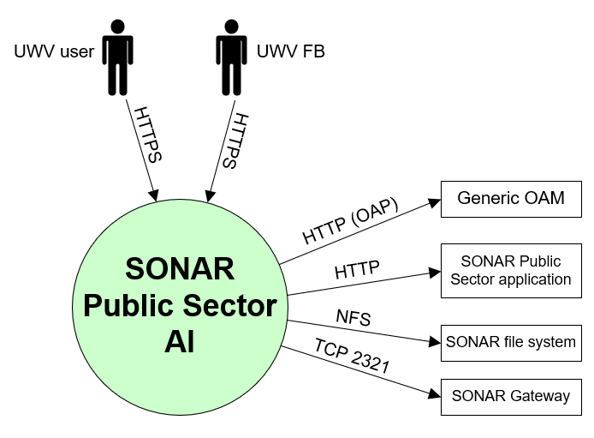

##### Entity UWV user

|  |  |
| --- | --- |
| **Description** | UWV Sonar User. Web-based User Interface (inclusief Gemeente) |
| **Protocol and Port** | HTTPS (443) |
| **DC (Datacenter) connection** | Internal (within DXC datacenter) |
| **Direction** | Inbound (connection initiated by the entity) |
| **Direct connection** | Yes |
| **Security Controls** | Authorisation method or authentication method: Select (mandatory)  Use certificates: Select (mandatory)  Service account: Select (mandatory)  Other: <(only mention if applicable) other applicable security control related configuration>  Transport Layer Security (HTTPS), Role Based Access |
| **Number of users** | Transport Layer Security (HTTPS), Role Based Access |
| **Number of transactions** | ~5000 avg. concurrent |
| **Frequency of transactions** | 50.000 per day in total for Siebel (2012, no recent data available) |
| **Volume of data in transit** | Daily |

##### Entity UWV FB

|  |  |
| --- | --- |
| **Description** | UWV Functional Support. |
| **Protocol and Port** | HTTPS (443) |
| **DC (Datacenter) connection** | Internal |
| **Direction** | Inbound |
| **Direct connection** | Yes |
| **Security Controls** | Authorisation method or authentication method: Select (mandatory)  Use certificates: Select (mandatory)  Service account: Select (mandatory)  Other: <(only mention if applicable) other applicable security control related configuration>  Transport Layer Security (HTTPS), Role Based Access |
| **Number of users** | Less than 10 |
| **Number of transactions** | Not specified |
| **Frequency of transactions** | Not specified |
| **Volume of data in transit** | Low |

##### Entity Generic OAM

|  |  |
| --- | --- |
| **Description** | User authentication providing single sign-on for Sonar users using Generic OAM. OAM is connecting to the OID instance of Sonar  Oracle Webgate component running on the Public sector webserver connects via https to the Detached Credential Collector (DCC) of Generic OAM - Oracle Access Manager. OAM validates the user credentials via LDAPS in the Oracle Internet Directory (OID). This OID instance is part of the Sonar CI. |
| **Protocol and Port** | OAP (5575) |
| **DC (Datacenter) connection** | Internal |
| **Direction** | Outbound |
| **Direct connection** | Yes |
| **Security Controls** | Authorisation method or authentication method: Select (mandatory)  Use certificates: Select (mandatory)  Service account: Select (mandatory)  Other: <(only mention if applicable) other applicable security control related configuration>  Role Based Access, Secure transport |
| **Number of users** | 1 |
| **Number of transactions** | Not specified |
| **Frequency of transactions** | Not specified |
| **Volume of data in transit** | Low |

##### Entity SONAR Public Sector application

|  |  |
| --- | --- |
| **Description** | Access to the SONAR Public Sector back-end |
| **Protocol and Port** | HTTP (80) |
| **DC (Datacenter) connection** | Internal |
| **Direction** | Outbound |
| **Direct connection** | Yes |
| **Security Controls** | Authorisation method or authentication method: Select (mandatory)  Use certificates: Select (mandatory)  Service account: Select (mandatory)  Other: <(only mention if applicable) other applicable security control related configuration> |
| **Number of users** | Not specified |
| **Number of transactions** | Not specified |
| **Frequency of transactions** | Not specified |
| **Volume of data in transit** | Not specified |

##### Entity SONAR file system

|  |  |
| --- | --- |
| **Description** | Access to SONAR file system |
| **Protocol and Port** | NFS (2049,111) |
| **DC (Datacenter) connection** | Internal |
| **Direction** | Outbound |
| **Direct connection** | Yes |
| **Security Controls** | Authorisation method or authentication method: Select (mandatory)  Use certificates: Select (mandatory)  Service account: Select (mandatory)  Other: <(only mention if applicable) other applicable security control related configuration>  From HLD: Not specified |
| **Number of users** | Not specified |
| **Number of transactions** | Not specified |
| **Frequency of transactions** | Not specified |
| **Volume of data in transit** | Not specified |

##### Entity SONAR Gateway

|  |  |
| --- | --- |
| **Description** | Access to config and status data |
| **Protocol and Port** | Proprietary (2321) |
| **DC (Datacenter) connection** | Internal |
| **Direction** | Outbound |
| **Direct connection** | Yes |
| **Security Controls** | Authorisation method or authentication method: Select (mandatory)  Use certificates: Select (mandatory)  Service account: Select (mandatory)  Other: <(only mention if applicable) other applicable security control related configuration>  From HLD: Not specified |
| **Number of users** | Not specified |
| **Number of transactions** | Not specified |
| **Frequency of transactions** | Not specified |
| **Volume of data in transit** | Not specified |

#### SONAR Public Sector application

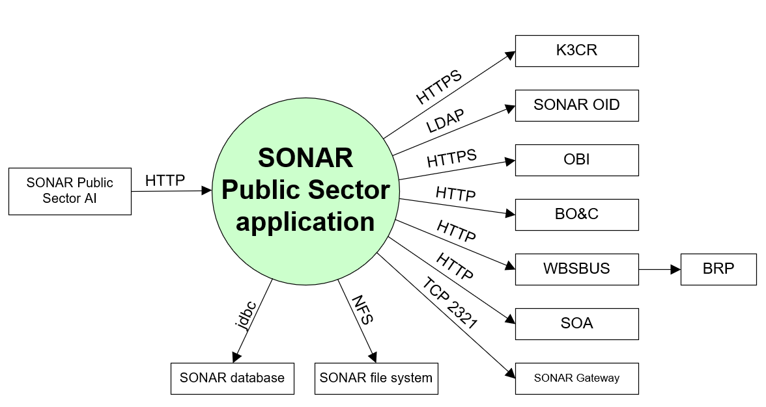

##### Entity Public Sector AI

|  |  |
| --- | --- |
| **Description** | Access from the SONAR Public Sector application interface to the SONAR Public Sector back-end |
| **Protocol and Port** | HTTP (80) |
| **DC (Datacenter) connection** | Internal |
| **Direction** | Inbound |
| **Direct connection** | Yes |
| **Security Controls** | Authorisation method or authentication method: Select (mandatory)  Use certificates: Select (mandatory)  Service account: Select (mandatory)  Other: <(only mention if applicable) other applicable security control related configuration>  From HLD: Not specified |
| **Number of users** | Not specified |
| **Number of transactions** | Not specified |
| **Frequency of transactions** | Not specified |
| **Volume of data in transit** | Not specified |

##### Entity K3CR

|  |  |
| --- | --- |
| **Description** | K3CR url |
| **Protocol and Port** | HTTPS (443) |
| **DC (Datacenter) connection** | Internal |
| **Direction** | Outbound |
| **Direct connection** | Yes |
| **Security Controls** | Authorisation method or authentication method: Select (mandatory)  Use certificates: Select (mandatory)  Service account: Select (mandatory)  Other: <(only mention if applicable) other applicable security control related configuration>  From HLD: Secure transport |
| **Number of users** | Not specified |
| **Number of transactions** | Not specified |
| **Frequency of transactions** | Not specified |
| **Volume of data in transit** | Not specified |

##### Entity SONAR OID

|  |  |
| --- | --- |
| **Description** | Retrieve users and groups from SONAR OID |
| **Protocol and Port** | LDAP (389) |
| **DC (Datacenter) connection** | Internal |
| **Direction** | Outbound |
| **Direct connection** | Yes |
| **Security Controls** | Authorisation method or authentication method: Select (mandatory)  Use certificates: Select (mandatory)  Service account: Select (mandatory)  Other: <(only mention if applicable) other applicable security control related configuration>  From HLD: Not specified |
| **Number of users** | Not specified |
| **Number of transactions** | Not specified |
| **Frequency of transactions** | Not specified |
| **Volume of data in transit** | Not specified |

##### Entity OBI

|  |  |
| --- | --- |
| **Description** | Access OBI in iFrame |
| **Protocol and Port** | HTTPS (7024) |
| **DC (Datacenter) connection** | Internal |
| **Direction** | Outbound |
| **Direct connection** | Yes |
| **Security Controls** | Authorisation method or authentication method: Select (mandatory)  Use certificates: Select (mandatory)  Service account: Select (mandatory)  Other: <(only mention if applicable) other applicable security control related configuration>  From HLD: Secure transport |
| **Number of users** | Not specified |
| **Number of transactions** | Not specified |
| **Frequency of transactions** | Not specified |
| **Volume of data in transit** | Low |

##### Entity BO&C (Werk.nl backend)

|  |  |
| --- | --- |
| **Description** | BO&C (Beroepen, Opleidingen, Competenties en Cursussen)  Client to BO&C web application: Beroepen, Opleidingen, Competenties en Cursussen informatie |
| **Protocol and Port** | HTTP (80) |
| **DC (Datacenter) connection** | Internal |
| **Direction** | Outbound |
| **Direct connection** | Yes |
| **Security Controls** | Authorisation method or authentication method: Select (mandatory)  Use certificates: Select (mandatory)  Service account: Select (mandatory)  Other: <(only mention if applicable) other applicable security control related configuration>  From HLD: Role Based Access |
| **Number of users** | 1 |
| **Number of transactions** | Not specified |
| **Frequency of transactions** | Not specified |
| **Volume of data in transit** | Low |

##### Entity BRP

|  |  |
| --- | --- |
| **Description** | BRP url (through WBSBUS) |
| **Protocol and Port** | HTTP (80) |
| **DC (Datacenter) connection** | Internal |
| **Direction** | Outbound |
| **Direct connection** | No via WBSBUS |
| **Security Controls** | Authorisation method or authentication method: Select (mandatory)  Use certificates: Select (mandatory)  Service account: Select (mandatory)  Other: <(only mention if applicable) other applicable security control related configuration>  From HLD: Not specified |
| **Number of users** | Not specified |
| **Number of transactions** | Not specified |
| **Frequency of transactions** | Not specified |
| **Volume of data in transit** | Not specified |

##### Entity SOA

|  |  |
| --- | --- |
| **Description** | Several functions are accessed through SOA |
| **Protocol and Port** | HTTP (80) |
| **DC (Datacenter) connection** | Internal |
| **Direction** | Outbound |
| **Direct connection** | Yes |
| **Security Controls** | Authorisation method or authentication method: Select (mandatory)  Use certificates: Select (mandatory)  Service account: Select (mandatory)  Other: <(only mention if applicable) other applicable security control related configuration>  From HLD: Not specified |
| **Number of users** | Not specified |
| **Number of transactions** | Not specified |
| **Frequency of transactions** | Not specified |
| **Volume of data in transit** | Not specified |

##### Entity SONAR Gateway

|  |  |
| --- | --- |
| **Description** | Access to config and status data |
| **Protocol and Port** | Proprietary (2321) |
| **DC (Datacenter) connection** | Internal |
| **Direction** | Outbound |
| **Direct connection** | Yes |
| **Security Controls** | Authorisation method or authentication method: Select (mandatory)  Use certificates: Select (mandatory)  Service account: Select (mandatory)  Other: <(only mention if applicable) other applicable security control related configuration>  From HLD: Not specified |
| **Number of users** | Not specified |
| **Number of transactions** | Not specified |
| **Frequency of transactions** | Not specified |
| **Volume of data in transit** | Not specified |

##### Entity SONAR file system

|  |  |
| --- | --- |
| **Description** | Access to SONAR file system |
| **Protocol and Port** | NFS (2049,111) |
| **DC (Datacenter) connection** | Internal |
| **Direction** | Outbound |
| **Direct connection** | Yes |
| **Security Controls** | Authorisation method or authentication method: Select (mandatory)  Use certificates: Select (mandatory)  Service account: Select (mandatory)  Other: <(only mention if applicable) other applicable security control related configuration>  From HLD: Not specified |
| **Number of users** | Not specified |
| **Number of transactions** | Not specified |
| **Frequency of transactions** | Not specified |
| **Volume of data in transit** | Not specified |

##### Entity SONAR Database

|  |  |
| --- | --- |
| **Description** | Access to SONAR Database |
| **Protocol and Port** | Oracle client (1521) |
| **DC (Datacenter) connection** | Internal |
| **Direction** | Outbound |
| **Direct connection** | Yes |
| **Security Controls** | Authorisation method or authentication method: Select (mandatory)  Use certificates: Select (mandatory)  Service account: Select (mandatory)  Other: <(only mention if applicable) other applicable security control related configuration>  From HLD: Not specified |
| **Number of users** | Not specified |
| **Number of transactions** | Not specified |
| **Frequency of transactions** | Not specified |
| **Volume of data in transit** | Not specified |

#### SONAR EAI AI

(e-Business Application Integration – Application Interface)

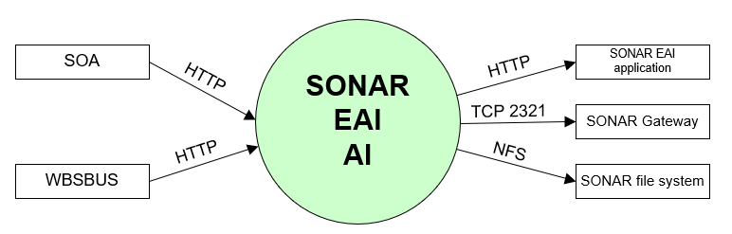

##### WBSBUS

|  |  |
| --- | --- |
| **Description** | system communicating (through load balancer) with external SONAR businesses and users, among others: SMF, EAED, PeopleSoft, Prisma Satellite, K3CR, Werk.nl (Werkmap), E-Intake, DWH and DIM (database link to SONAR database), KOA aanvraag WW, BRP url |
| **Protocol and Port** | HTTP (8080) |
| **DC (Datacenter) connection** | Internal |
| **Direction** | Inbound |
| **Direct connection** | Yes |
| **Security Controls** | Authorisation method or authentication method: Select (mandatory)  Use certificates: Select (mandatory)  Service account: Select (mandatory)  Other: <(only mention if applicable) other applicable security control related configuration>  From HLD: Not specified |
| **Number of users** | Not specified |
| **Number of transactions** | Not specified |
| **Frequency of transactions** | Not specified |
| **Volume of data in transit** | Not specified |

##### SOA

|  |  |
| --- | --- |
| **Description** | SOA connections through the load balancer |
| **Protocol and Port** | HTTP (8080) |
| **DC (Datacenter) connection** | Internal |
| **Direction** | Inbound |
| **Direct connection** | Yes |
| **Security Controls** | Authorisation method or authentication method: Select (mandatory)  Use certificates: Select (mandatory)  Service account: Select (mandatory)  Other: <(only mention if applicable) other applicable security control related configuration>  From HLD: Not specified |
| **Number of users** | Not specified |
| **Number of transactions** | Not specified |
| **Frequency of transactions** | Not specified |
| **Volume of data in transit** | Not specified |

##### SONAR EAI Application

|  |  |
| --- | --- |
| **Description** | Access to the SONAR EAI back-end |
| **Protocol and Port** | HTTP (8080) |
| **DC (Datacenter) connection** | Internal |
| **Direction** | Outbound |
| **Direct connection** | Yes |
| **Security Controls** | Authorisation method or authentication method: Select (mandatory)  Use certificates: Select (mandatory)  Service account: Select (mandatory)  Other: <(only mention if applicable) other applicable security control related configuration>  From HLD: Not specified |
| **Number of users** | Not specified |
| **Number of transactions** | Not specified |
| **Frequency of transactions** | Not specified |
| **Volume of data in transit** | Not specified |

##### SONAR Gateway

|  |  |
| --- | --- |
| **Description** | Access to config and status data |
| **Protocol and Port** | Proprietary (2321) |
| **DC (Datacenter) connection** | Internal |
| **Direction** | Outbound |
| **Direct connection** | Yes |
| **Security Controls** | Authorisation method or authentication method: Select (mandatory)  Use certificates: Select (mandatory)  Service account: Select (mandatory)  Other: <(only mention if applicable) other applicable security control related configuration>  From HLD: Not specified |
| **Number of users** | Not specified |
| **Number of transactions** | Not specified |
| **Frequency of transactions** | Not specified |
| **Volume of data in transit** | Not specified |

##### SONAR file system

|  |  |
| --- | --- |
| **Description** | Access to SONAR file system |
| **Protocol and Port** | NFS (2049,111) |
| **DC (Datacenter) connection** | Internal |
| **Direction** | Outbound |
| **Direct connection** | Yes |
| **Security Controls** | Authorisation method or authentication method: Select (mandatory)  Use certificates: Select (mandatory)  Service account: Select (mandatory)  Other: <(only mention if applicable) other applicable security control related configuration>  From HLD: Not specified |
| **Number of users** | Not specified |
| **Number of transactions** | Not specified |
| **Frequency of transactions** | Not specified |
| **Volume of data in transit** | Not specified |

#### SONAR EAI application

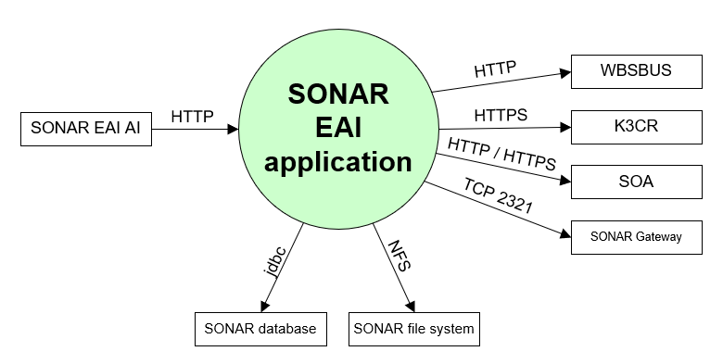

##### SONAR EAI AI

|  |  |
| --- | --- |
| **Description** | Access from the SONAR EAI application interface to the SONAR EAI back-end |
| **Protocol and Port** | HTTP (80) |
| **DC (Datacenter) connection** | Internal |
| **Direction** | Inbound |
| **Direct connection** | Yes |
| **Security Controls** | Authorisation method or authentication method: Select (mandatory)  Use certificates: Select (mandatory)  Service account: Select (mandatory)  Other: <(only mention if applicable) other applicable security control related configuration>  From HLD: Not specified |
| **Number of users** | Not specified |
| **Number of transactions** | Not specified |
| **Frequency of transactions** | Not specified |
| **Volume of data in transit** | Not specified |

##### WBSBUS

|  |  |
| --- | --- |
| **Description** | system communicating with external SONAR businesses and users, among others: SMF, EAED, PeopleSoft, Prisma Satellite, K3CR, Werk.nl (Werkmap), E-Intake, DWH and DIM (database link to SONAR database), KOA aanvraag WW, BRP url |
| **Protocol and Port** | HTTP (80) |
| **DC (Datacenter) connection** | Internal |
| **Direction** | Outbound |
| **Direct connection** | Yes |
| **Security Controls** | Authorisation method or authentication method: Select (mandatory)  Use certificates: Select (mandatory)  Service account: Select (mandatory)  Other: <(only mention if applicable) other applicable security control related configuration>  From HLD: Not specified |
| **Number of users** | Not specified |
| **Number of transactions** | Not specified |
| **Frequency of transactions** | Not specified |
| **Volume of data in transit** | Not specified |

##### K3CR

|  |  |
| --- | --- |
| **Description** | K3CR url |
| **Protocol and Port** | HTTPS (443) |
| **DC (Datacenter) connection** | Internal |
| **Direction** | Outbound |
| **Direct connection** | Yes |
| **Security Controls** | Authorisation method or authentication method: Select (mandatory)  Use certificates: Select (mandatory)  Service account: Select (mandatory)  Other: <(only mention if applicable) other applicable security control related configuration>  From HLD: Not specified |
| **Number of users** | Not specified |
| **Number of transactions** | Not specified |
| **Frequency of transactions** | Not specified |
| **Volume of data in transit** | Not specified |

##### SOA

|  |  |
| --- | --- |
| **Description** | Several functions are accessed through SOA |
| **Protocol and Port** | HTTP (80), HTTPS (443) |
| **DC (Datacenter) connection** | Internal |
| **Direction** | Outbound |
| **Direct connection** | Yes |
| **Security Controls** | Authorisation method or authentication method: Select (mandatory)  Use certificates: Select (mandatory)  Service account: Select (mandatory)  Other: <(only mention if applicable) other applicable security control related configuration>  From HLD: Not specified |
| **Number of users** | Not specified |
| **Number of transactions** | Not specified |
| **Frequency of transactions** | Not specified |
| **Volume of data in transit** | Not specified |

##### Entity SONAR Gateway

|  |  |
| --- | --- |
| **Description** | Access to config and status data |
| **Protocol and Port** | Proprietary (2321) |
| **DC (Datacenter) connection** | Internal |
| **Direction** | Outbound |
| **Direct connection** | Yes |
| **Security Controls** | Authorisation method or authentication method: Select (mandatory)  Use certificates: Select (mandatory)  Service account: Select (mandatory)  Other: <(only mention if applicable) other applicable security control related configuration>  From HLD: Not specified |
| **Number of users** | Not specified |
| **Number of transactions** | Not specified |
| **Frequency of transactions** | Not specified |
| **Volume of data in transit** | Not specified |

##### Entity SONAR file system

|  |  |
| --- | --- |
| **Description** | Access to SONAR file system |
| **Protocol and Port** | NFS (2049,111) |
| **DC (Datacenter) connection** | Internal |
| **Direction** | Outbound |
| **Direct connection** | Yes |
| **Security Controls** | Authorisation method or authentication method: Select (mandatory)  Use certificates: Select (mandatory)  Service account: Select (mandatory)  Other: <(only mention if applicable) other applicable security control related configuration>  From HLD: Not specified |
| **Number of users** | Not specified |
| **Number of transactions** | Not specified |
| **Frequency of transactions** | Not specified |
| **Volume of data in transit** | Not specified |

##### Entity SONAR Database

|  |  |
| --- | --- |
| **Description** | Access to SONAR Database |
| **Protocol and Port** | Oracle client (1521) |
| **DC (Datacenter) connection** | Internal |
| **Direction** | Outbound |
| **Direct connection** | Yes |
| **Security Controls** | Authorisation method or authentication method: Select (mandatory)  Use certificates: Select (mandatory)  Service account: Select (mandatory)  Other: <(only mention if applicable) other applicable security control related configuration>  From HLD: Not specified |
| **Number of users** | Not specified |
| **Number of transactions** | Not specified |
| **Frequency of transactions** | Not specified |
| **Volume of data in transit** | Not specified |

#### SONAR Document / Correspondence

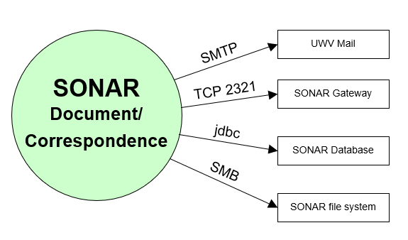

##### Entity UWV Mail

|  |  |
| --- | --- |
| **Description** | Production: KPN Mail relay for sending mail to unemployed clients  Acceptance: Generieke Mail services for testing mail functionality |
| **Protocol and Port** | SMTP (25) with STARTTLS option |
| **DC (Datacenter) connection** | External |
| **Direction** | Outbound |
| **Direct connection** | Yes |
| **Security Controls** | Authorisation method or authentication method: Select (mandatory)  Use certificates: Select (mandatory)  Service account: Select (mandatory)  Other: <(only mention if applicable) other applicable security control related configuration>  From HLD: Role Based Access, Secure transport |
| **Number of users** | Not specified |
| **Number of transactions** | Not specified |
| **Frequency of transactions** | Not specified |
| **Volume of data in transit** | Not specified |

##### Entity SONAR Gateway

|  |  |
| --- | --- |
| **Description** | Access to config and status data |
| **Protocol and Port** | Proprietary (2321) |
| **DC (Datacenter) connection** | Internal |
| **Direction** | Outbound |
| **Direct connection** | Yes |
| **Security Controls** | Authorisation method or authentication method: Select (mandatory)  Use certificates: Select (mandatory)  Service account: Select (mandatory)  Other: <(only mention if applicable) other applicable security control related configuration>  From HLD: Not specified |
| **Number of users** | Not specified |
| **Number of transactions** | Not specified |
| **Frequency of transactions** | Not specified |
| **Volume of data in transit** | Not specified |

##### Entity SONAR file system

|  |  |
| --- | --- |
| **Description** | Access to SONAR file system |
| **Protocol and Port** | SMB v3 (445) |
| **DC (Datacenter) connection** | Internal |
| **Direction** | Outbound |
| **Direct connection** | Yes |
| **Security Controls** | Authorisation method or authentication method: Select (mandatory)  Use certificates: Select (mandatory)  Service account: Select (mandatory)  Other: <(only mention if applicable) other applicable security control related configuration>  From HLD: Not specified |
| **Number of users** | Not specified |
| **Number of transactions** | Not specified |
| **Frequency of transactions** | Not specified |
| **Volume of data in transit** | Not specified |

##### Entity SONAR Database

|  |  |
| --- | --- |
| **Description** | Access to SONAR Database |
| **Protocol and Port** | Oracle client (1521) |
| **DC (Datacenter) connection** | Internal |
| **Direction** | Outbound |
| **Direct connection** | Yes |
| **Security Controls** | Authorisation method or authentication method: Select (mandatory)  Use certificates: Select (mandatory)  Service account: Select (mandatory)  Other: <(only mention if applicable) other applicable security control related configuration>  From HLD: Not specified |
| **Number of users** | Not specified |
| **Number of transactions** | Not specified |
| **Frequency of transactions** | Not specified |
| **Volume of data in transit** | Not specified |

#### SONAR Gateway

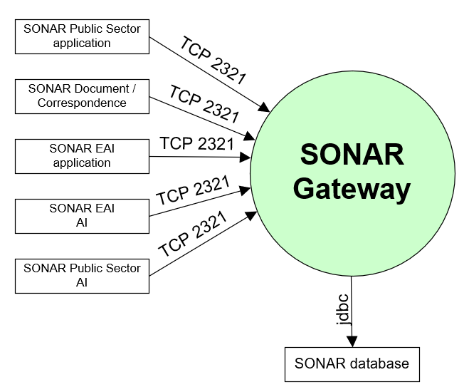

##### Entity SONAR Public Sector application

|  |  |
| --- | --- |
| **Description** | Access to config and status data |
| **Protocol and Port** | Proprietary (2321) |
| **DC (Datacenter) connection** | Internal |
| **Direction** | Inbound |
| **Direct connection** | Yes |
| **Security Controls** | Authorisation method or authentication method: Select (mandatory)  Use certificates: Select (mandatory)  Service account: Select (mandatory)  Other: <(only mention if applicable) other applicable security control related configuration> |
| **Number of users** | Not specified |
| **Number of transactions** | Not specified |
| **Frequency of transactions** | Not specified |
| **Volume of data in transit** | Not specified |

##### Entity SONAR Document / Correspondence

|  |  |
| --- | --- |
| **Description** | Access to config and status data |
| **Protocol and Port** | Proprietary (2321) |
| **DC (Datacenter) connection** | Internal |
| **Direction** | Inbound |
| **Direct connection** | Yes |
| **Security Controls** | Authorisation method or authentication method: Select (mandatory)  Use certificates: Select (mandatory)  Service account: Select (mandatory)  Other: <(only mention if applicable) other applicable security control related configuration>  From HLD: Not specified |
| **Number of users** | Not specified |
| **Number of transactions** | Not specified |
| **Frequency of transactions** | Not specified |
| **Volume of data in transit** | Not specified |

##### SONAR EAI Application

|  |  |
| --- | --- |
| **Description** | Access to config and status data |
| **Protocol and Port** | Proprietary (2321) |
| **DC (Datacenter) connection** | Internal |
| **Direction** | Inbound |
| **Direct connection** | Yes |
| **Security Controls** | Authorisation method or authentication method: Select (mandatory)  Use certificates: Select (mandatory)  Service account: Select (mandatory)  Other: <(only mention if applicable) other applicable security control related configuration>  From HLD: Not specified |
| **Number of users** | Not specified |
| **Number of transactions** | Not specified |
| **Frequency of transactions** | Not specified |
| **Volume of data in transit** | Not specified |

##### SONAR EAI AI

|  |  |
| --- | --- |
| **Description** | Access to config and status data |
| **Protocol and Port** | Proprietary (2321) |
| **DC (Datacenter) connection** | Internal |
| **Direction** | Inbound |
| **Direct connection** | Yes |
| **Security Controls** | Authorisation method or authentication method: Select (mandatory)  Use certificates: Select (mandatory)  Service account: Select (mandatory)  Other: <(only mention if applicable) other applicable security control related configuration>  From HLD: Not specified |
| **Number of users** | Not specified |
| **Number of transactions** | Not specified |
| **Frequency of transactions** | Not specified |
| **Volume of data in transit** | Not specified |

##### Entity SONAR Public Sector AI

|  |  |
| --- | --- |
| **Description** | Access to config and status data |
| **Protocol and Port** | Proprietary (2321) |
| **DC (Datacenter) connection** | Internal |
| **Direction** | Inbound |
| **Direct connection** | Yes |
| **Security Controls** | Authorisation method or authentication method: Select (mandatory)  Use certificates: Select (mandatory)  Service account: Select (mandatory)  Other: <(only mention if applicable) other applicable security control related configuration>  From HLD: Not specified |
| **Number of users** | Not specified |
| **Number of transactions** | Not specified |
| **Frequency of transactions** | Not specified |
| **Volume of data in transit** | Not specified |

##### Entity SONAR Database

|  |  |
| --- | --- |
| **Description** | Access to SONAR Database |
| **Protocol and Port** | Oracle client (1521) |
| **DC (Datacenter) connection** | Internal |
| **Direction** | Outbound |
| **Direct connection** | Yes |
| **Security Controls** | Authorisation method or authentication method: Select (mandatory)  Use certificates: Select (mandatory)  Service account: Select (mandatory)  Other: <(only mention if applicable) other applicable security control related configuration>  From HLD: Not specified |
| **Number of users** | Not specified |
| **Number of transactions** | Not specified |
| **Frequency of transactions** | Not specified |
| **Volume of data in transit** | Not specified |

#### SONAR database

##### Entity UWV FB

|  |  |
| --- | --- |
| **Description** | UWV Functional Support. |
| **Protocol and Port** | HTTPS (443) |
| **DC (Datacenter) connection** | Internal |
| **Direction** | Inbound |
| **Direct connection** | No via UCRA |
| **Security Controls** | Authorisation method or authentication method: Select (mandatory)  Use certificates: Select (mandatory)  Service account: Select (mandatory)  Other: <(only mention if applicable) other applicable security control related configuration>  From HLD: Not specified |
| **Number of users** | 12 - 20 |
| **Number of transactions** | Not specified |
| **Frequency of transactions** | Not specified |
| **Volume of data in transit** | Low |

##### Entity Werk.nl database

|  |  |
| --- | --- |
| **Description** | Support to compare Sonar SKB |
| **Protocol and Port** | jdbc (1521) |
| **DC (Datacenter) connection** | Internal |
| **Direction** | Outbound |
| **Direct connection** | Yes |
| **Security Controls** | Authorisation method or authentication method: Select (mandatory)  Use certificates: Select (mandatory)  Service account: Select (mandatory)  Other: <(only mention if applicable) other applicable security control related configuration>  From HLD: Not specified |
| **Number of users** | Not specified |
| **Number of transactions** | Not specified |
| **Frequency of transactions** | Not specified |
| **Volume of data in transit** | Not specified |

##### Entity SONAR Logical Standby database

|  |  |
| --- | --- |
| **Description** | Active DataGuard connection to the logical standby |
| **Protocol and Port** | jdbc (1521) |
| **DC (Datacenter) connection** | Internal |
| **Direction** | Outbound |
| **Direct connection** | Yes |
| **Security Controls** | Authorisation method or authentication method: Select (mandatory)  Use certificates: Select (mandatory)  Service account: Select (mandatory)  Other: <(only mention if applicable) other applicable security control related configuration>  From HLD: Not specified |
| **Number of users** | Not specified |
| **Number of transactions** | Not specified |
| **Frequency of transactions** | Not specified |
| **Volume of data in transit** | Not specified |

##### Entity Generic logging service

|  |  |
| --- | --- |
| **Description** | Shell script running on the database server that makes a coonection to the Generic logging service to transfer the LoMo (logging and Monitoring) log files. The Generic logging service provides the file via SI file transfer to QRADAR |
| **Protocol and Port** | SSH (22) |
| **DC (Datacenter) connection** | Internal |
| **Direction** | Outbound |
| **Direct connection** | Yes |
| **Security Controls** | Authorisation method or authentication method: Select (mandatory)  Use certificates: Select (mandatory)  Service account: Select (mandatory)  Other: <(only mention if applicable) other applicable security control related configuration>  From HLD: Not specified |
| **Number of users** | Not specified |
| **Number of transactions** | Not specified |
| **Frequency of transactions** | Not specified |
| **Volume of data in transit** | Not specified |

##### Entity SONAR Document / Correspodence

|  |  |
| --- | --- |
| **Description** | Access to SONAR database |
| **Protocol and Port** | Oracle client (1521) |
| **DC (Datacenter) connection** | Internal |
| **Direction** | Inbound |
| **Direct connection** | Yes |
| **Security Controls** | Authorisation method or authentication method: Select (mandatory)  Use certificates: Select (mandatory)  Service account: Select (mandatory)  Other: <(only mention if applicable) other applicable security control related configuration>  From HLD: Not specified |
| **Number of users** | Not specified |
| **Number of transactions** | Not specified |
| **Frequency of transactions** | Not specified |
| **Volume of data in transit** | Not specified |

##### Entity SONAR Gateway

|  |  |
| --- | --- |
| **Description** | Access to SONAR database |
| **Protocol and Port** | Oracle client (1521) |
| **DC (Datacenter) connection** | Internal |
| **Direction** | Inbound |
| **Direct connection** | Yes |
| **Security Controls** | Authorisation method or authentication method: Select (mandatory)  Use certificates: Select (mandatory)  Service account: Select (mandatory)  Other: <(only mention if applicable) other applicable security control related configuration>  From HLD: Not specified |
| **Number of users** | Not specified |
| **Number of transactions** | Not specified |
| **Frequency of transactions** | Not specified |
| **Volume of data in transit** | Not specified |

##### Entity SONAR EAI application

|  |  |
| --- | --- |
| **Description** | Access to SONAR database |
| **Protocol and Port** | Oracle client (1521) |
| **DC (Datacenter) connection** | Internal |
| **Direction** | Inbound |
| **Direct connection** | Yes |
| **Security Controls** | Authorisation method or authentication method: Select (mandatory)  Use certificates: Select (mandatory)  Service account: Select (mandatory)  Other: <(only mention if applicable) other applicable security control related configuration>  From HLD: Not specified |
| **Number of users** | Not specified |
| **Number of transactions** | Not specified |
| **Frequency of transactions** | Not specified |
| **Volume of data in transit** | Not specified |

##### Entity SONAR Public Sector application

|  |  |
| --- | --- |
| **Description** | Access to SONAR database |
| **Protocol and Port** | Oracle client (1521) |
| **DC (Datacenter) connection** | Internal |
| **Direction** | Inbound |
| **Direct connection** | Yes |
| **Security Controls** | Authorisation method or authentication method: Select (mandatory)  Use certificates: Select (mandatory)  Service account: Select (mandatory)  Other: <(only mention if applicable) other applicable security control related configuration>  From HLD: Not specified |
| **Number of users** | Not specified |
| **Number of transactions** | Not specified |
| **Frequency of transactions** | Not specified |
| **Volume of data in transit** | Not specified |

##### Entity SOA

|  |  |
| --- | --- |
| **Description** | Access to SONAR database |
| **Protocol and Port** | JMS (1521, 2484) |
| **DC (Datacenter) connection** | Internal |
| **Direction** | Inbound |
| **Direct connection** | Yes |
| **Security Controls** | Authorisation method or authentication method: Select (mandatory)  Use certificates: Select (mandatory)  Service account: Select (mandatory)  Other: <(only mention if applicable) other applicable security control related configuration>  From HLD: Not specified |
| **Number of users** | Not specified |
| **Number of transactions** | Not specified |
| **Frequency of transactions** | Not specified |
| **Volume of data in transit** | Not specified |

##### Entity WBSBUS

|  |  |
| --- | --- |
| **Description** | Access to SONAR database |
| **Protocol and Port** | Oracle client (1521, 2484) |
| **DC (Datacenter) connection** | Internal |
| **Direction** | Inbound |
| **Direct connection** | Yes |
| **Security Controls** | Authorisation method or authentication method: Select (mandatory)  Use certificates: Select (mandatory)  Service account: Select (mandatory)  Other: <(only mention if applicable) other applicable security control related configuration>  From HLD: Not specified |
| **Number of users** | Not specified |
| **Number of transactions** | Not specified |
| **Frequency of transactions** | Not specified |
| **Volume of data in transit** | Not specified |

##### Entity SONAR Staging

|  |  |
| --- | --- |
| **Description** | Provide templates |
| **Protocol and Port** | SFTP (22) |
| **DC (Datacenter) connection** | Internal |
| **Direction** | Inbound |
| **Direct connection** | Yes |
| **Security Controls** | Authorisation method or authentication method: Select (mandatory)  Use certificates: Select (mandatory)  Service account: Select (mandatory)  Other: <(only mention if applicable) other applicable security control related configuration>  From HLD: Not specified |
| **Number of users** | Not specified |
| **Number of transactions** | Not specified |
| **Frequency of transactions** | Not specified |
| **Volume of data in transit** | Not specified |

##### Entity UWV Mail

|  |  |
| --- | --- |
| **Description** | Sending mail notification to UWV FB from the SONAR DB servers |
| **Protocol and Port** | SMTP (25) |
| **DC (Datacenter) connection** | External |
| **Direction** | Outbound |
| **Direct connection** | Yes |
| **Security Controls** | Authorisation method or authentication method: Select (mandatory)  Use certificates: Select (mandatory)  Service account: Select (mandatory)  Other: <(only mention if applicable) other applicable security control related configuration>  From HLD: Not specified |
| **Number of users** | Not specified |
| **Number of transactions** | Not specified |
| **Frequency of transactions** | Not specified |
| **Volume of data in transit** | Not specified |

#### SONAR logical standby database

##### Entity UWV GB

|  |  |
| --- | --- |
| **Description** | UWV Functional Support |
| **Protocol and Port** | Oracle client (1521) |
| **DC (Datacenter) connection** | Internal |
| **Direction** | Inbound |
| **Direct connection** | No  Via: UCRA |
| **Security Controls** | Authorisation method or authentication method: Select (mandatory)  Use certificates: Select (mandatory)  Service account: Select (mandatory)  Other: <(only mention if applicable) other applicable security control related configuration>  From HLD: Not specified |
| **Number of users** | Less than 10 total assumed |
| **Number of transactions** | Not specified |
| **Frequency of transactions** | Not specified |
| **Volume of data in transit** | Low |

##### Entity Jobcoach

|  |  |
| --- | --- |
| **Description** | Export data of Logical Standby database used by Jobcoach department for generating reports. |
| **Protocol and Port** | FTP (21) |
| **DC (Datacenter) connection** | Internal |
| **Direction** | Outbound |
| **Direct connection** | No  Via: SI File-Transfer |
| **Security Controls** | Authorisation method or authentication method: RBAC (AD) (mandatory) Secure transport  Use certificates: Select (mandatory)  Service account: Select (mandatory)  Other: <(only mention if applicable) other applicable security control related configuration> |
| **Number of users** | 1 |
| **Number of transactions** | Not specified |
| **Frequency of transactions** | 1x week |
| **Volume of data in transit** | Low |

##### Entity SONAR database

|  |  |
| --- | --- |
| **Description** | Active DataGuard connection to the logical standby |
| **Protocol and Port** | jdbc (1521) |
| **DC (Datacenter) connection** | Internal |
| **Direction** | Inbound |
| **Direct connection** | Yes |
| **Security Controls** | Authorisation method or authentication method: Select (mandatory)  Use certificates: Select (mandatory)  Service account: Select (mandatory)  Other: <(only mention if applicable) other applicable security control related configuration>  From HLD: Not specified |
| **Number of users** | Not specified |
| **Number of transactions** | Not specified |
| **Frequency of transactions** | Not specified |
| **Volume of data in transit** | Not specified |

##### Entity Elise

|  |  |
| --- | --- |
| **Description** | Elise DB connection to the logical standby |
| **Protocol and Port** | jdbc (1521) |
| **DC (Datacenter) connection** | Internal |
| **Direction** | Inbound |
| **Direct connection** | Yes |
| **Security Controls** | Authorisation method or authentication method: Select (mandatory)  Use certificates: Select (mandatory)  Service account: Select (mandatory)  Other: <(only mention if applicable) other applicable security control related configuration>  From HLD: Not specified |
| **Number of users** | Not specified |
| **Number of transactions** | Not specified |
| **Frequency of transactions** | Not specified |
| **Volume of data in transit** | Not specified |

##### Entity DWH

|  |  |
| --- | --- |
| **Description** | DWH DB connection to the logical standby |
| **Protocol and Port** | jdbc (1521) |
| **DC (Datacenter) connection** | Internal |
| **Direction** | Inbound |
| **Direct connection** | Yes |
| **Security Controls** | Authorisation method or authentication method: Select (mandatory)  Use certificates: Select (mandatory)  Service account: Select (mandatory)  Other: <(only mention if applicable) other applicable security control related configuration>  From HLD: Not specified |
| **Number of users** | Not specified |
| **Number of transactions** | Not specified |
| **Frequency of transactions** | Not specified |
| **Volume of data in transit** | Not specified |

##### DIM

|  |  |
| --- | --- |
| **Description** | DIM DB connection to the logical standby |
| **Protocol and Port** | jdbc (1521) ???? |
| **DC (Datacenter) connection** | internal |
| **Direction** | inbound |
| **Direct connection** | yes |
| **Security Controls** | Not specified |
| **Number of users** | Not specified |
| **Number of transactions** | Not specified |
| **Frequency of transactions** | Not specified |
| **Volume of data** | Not specified |

##### Entity OBI

|  |  |
| --- | --- |
| **Description** | OBI DB connection to the logical standby |
| **Protocol and Port** | jdbc (1521) |
| **DC (Datacenter) connection** | Internal |
| **Direction** | Inbound |
| **Direct connection** | Yes |
| **Security Controls** | Authorisation method or authentication method: Select (mandatory)  Use certificates: Select (mandatory)  Service account: Select (mandatory)  Other: <(only mention if applicable) other applicable security control related configuration>  From HLD: Not specified |
| **Number of users** | Not specified |
| **Number of transactions** | Not specified |
| **Frequency of transactions** | Not specified |
| **Volume of data in transit** | Not specified |

##### Entity CDK

|  |  |
| --- | --- |
| **Description** | Queries for SUWI inkijk |
| **Protocol and Port** | jdbc (1521) |
| **DC (Datacenter) connection** | Internal |
| **Direction** | Inbound |
| **Direct connection** | Yes |
| **Security Controls** | Authorisation method or authentication method: Select (mandatory)  Use certificates: Select (mandatory)  Service account: Select (mandatory)  Other: <(only mention if applicable) other applicable security control related configuration>  From HLD: Not specified |
| **Number of users** | Not specified |
| **Number of transactions** | Not specified |
| **Frequency of transactions** | Not specified |
| **Volume of data in transit** | Not specified |

##### KVB

|  |  |
| --- | --- |
| **Description** | KVB DB connection to the logical standby |
| **Protocol and Port** | jdbc (1521) |
| **DC (Datacenter) connection** | Internal |
| **Direction** | Inbound |
| **Direct connection** | Yes |
| **Security Controls** | Authorisation method or authentication method: Select (mandatory)  Use certificates: Select (mandatory)  Service account: Select (mandatory)  Other: <(only mention if applicable) other applicable security control related configuration>  From HLD: Not specified |
| **Number of users** | Not specified |
| **Number of transactions** | Not specified |
| **Frequency of transactions** | Not specified |
| **Volume of data in transit** | Not specified |

#### SONAR File system

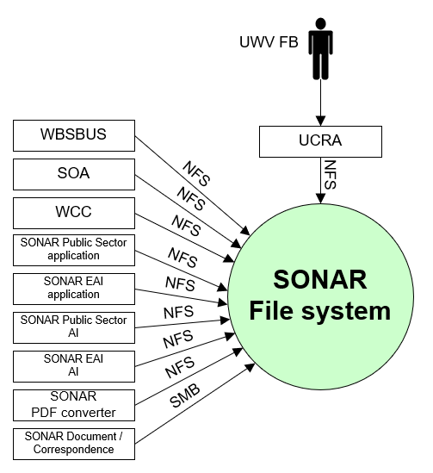

##### Entity UWV FB

|  |  |
| --- | --- |
| **Description** | UWV Functional Support – access to samba share |
| **Protocol and Port** | SMB v3 (445) |
| **DC (Datacenter) connection** | Internal |
| **Direction** | Inbound |
| **Direct connection** | No  Via: UCRA |
| **Security Controls** | Authorisation method or authentication method: Select (mandatory)  Use certificates: Select (mandatory)  Service account: Select (mandatory)  Other: <(only mention if applicable) other applicable security control related configuration>  From HLD: Not specified |
| **Number of users** | Less than 10 total assumed |
| **Number of transactions** | Not specified |
| **Frequency of transactions** | Not specified |
| **Volume of data in transit** | Low |

##### Entity SONAR Document / Correspondence

|  |  |
| --- | --- |
| **Description** | Access to Siebel file system |
| **Protocol and Port** | SMB v3 (445) |
| **DC (Datacenter) connection** | Internal |
| **Direction** | Inbound |
| **Direct connection** | Yes |
| **Security Controls** | Authorisation method or authentication method: Select (mandatory)  Use certificates: Select (mandatory)  Service account: Select (mandatory)  Other: <(only mention if applicable) other applicable security control related configuration>  From HLD: Not specified |
| **Number of users** | Not specified |
| **Number of transactions** | Not specified |
| **Frequency of transactions** | Not specified |
| **Volume of data in transit** | Not specified |

##### Entity SONAR PDF converter

|  |  |
| --- | --- |
| **Description** | Access to NFS |
| **Protocol and Port** | NFS v4 (2049,111) |
| **DC (Datacenter) connection** | Internal |
| **Direction** | Inbound |
| **Direct connection** | Yes |
| **Security Controls** | Authorisation method or authentication method: Select (mandatory)  Use certificates: Select (mandatory)  Service account: Select (mandatory)  Other: <(only mention if applicable) other applicable security control related configuration>  From HLD: Not specified |
| **Number of users** | Not specified |
| **Number of transactions** | Not specified |
| **Frequency of transactions** | Not specified |
| **Volume of data in transit** | Not specified |

##### Entity SONAR EAI AI

|  |  |
| --- | --- |
| **Description** | Access EAI Application servers to NFS |
| **Protocol and Port** | NFS v4 (2049,111) |
| **DC (Datacenter) connection** | Internal |
| **Direction** | Inbound |
| **Direct connection** | Yes |
| **Security Controls** | Authorisation method or authentication method: Select (mandatory)  Use certificates: Select (mandatory)  Service account: Select (mandatory)  Other: <(only mention if applicable) other applicable security control related configuration>  From HLD: Not specified |
| **Number of users** | Not specified |
| **Number of transactions** | Not specified |
| **Frequency of transactions** | Not specified |
| **Volume of data in transit** | Not specified |

##### Entity SONAR Public Sector AI

|  |  |
| --- | --- |
| **Description** | Access EAI Application servers to NFS |
| **Protocol and Port** | NFS v4 (2049,111) |
| **DC (Datacenter) connection** | Internal |
| **Direction** | Inbound |
| **Direct connection** | Yes |
| **Security Controls** | Authorisation method or authentication method: Select (mandatory)  Use certificates: Select (mandatory)  Service account: Select (mandatory)  Other: <(only mention if applicable) other applicable security control related configuration>  From HLD: Not specified |
| **Number of users** | Not specified |
| **Number of transactions** | Not specified |
| **Frequency of transactions** | Not specified |
| **Volume of data in transit** | Not specified |

##### Entity SONAR EAI application

|  |  |
| --- | --- |
| **Description** | Access EAI Application servers to NFS |
| **Protocol and Port** | NFS v4 (2049,111) |
| **DC (Datacenter) connection** | Internal |
| **Direction** | Inbound |
| **Direct connection** | Yes |
| **Security Controls** | Authorisation method or authentication method: Select (mandatory)  Use certificates: Select (mandatory)  Service account: Select (mandatory)  Other: <(only mention if applicable) other applicable security control related configuration>  From HLD: Not specified |
| **Number of users** | Not specified |
| **Number of transactions** | Not specified |
| **Frequency of transactions** | Not specified |
| **Volume of data in transit** | Not specified |

##### Entity Public Sector Application

|  |  |
| --- | --- |
| **Description** | Access NFS share /siebelfs/queues |
| **Protocol and Port** | NFS v4 (2049,111) |
| **DC (Datacenter) connection** | Internal |
| **Direction** | Inbound |
| **Direct connection** | Yes |
| **Security Controls** | Authorisation method or authentication method: Select (mandatory)  Use certificates: Select (mandatory)  Service account: Select (mandatory)  Other: <(only mention if applicable) other applicable security control related configuration>  From HLD: Not specified |
| **Number of users** | Not specified |
| **Number of transactions** | Not specified |
| **Frequency of transactions** | Not specified |
| **Volume of data in transit** | Not specified |

##### Entity WCC

|  |  |
| --- | --- |
| **Description** | To PDF share |
| **Protocol and Port** | NFS v4 (2049,111) |
| **DC (Datacenter) connection** | Internal |
| **Direction** | Inbound |
| **Direct connection** | Yes |
| **Security Controls** | Authorisation method or authentication method: Select (mandatory)  Use certificates: Select (mandatory)  Service account: Select (mandatory)  Other: <(only mention if applicable) other applicable security control related configuration>  From HLD: Not specified |
| **Number of users** | Not specified |
| **Number of transactions** | Not specified |
| **Frequency of transactions** | Not specified |
| **Volume of data in transit** | Not specified |

##### Entity SOA

|  |  |
| --- | --- |
| **Description** | To PDF share |
| **Protocol and Port** | NFS v4 (2049,111) |
| **DC (Datacenter) connection** | Internal |
| **Direction** | Inbound |
| **Direct connection** | Yes |
| **Security Controls** | Authorisation method or authentication method: Select (mandatory)  Use certificates: Select (mandatory)  Service account: Select (mandatory)  Other: <(only mention if applicable) other applicable security control related configuration>  From HLD: Not specified |
| **Number of users** | Not specified |
| **Number of transactions** | Not specified |
| **Frequency of transactions** | Not specified |
| **Volume of data in transit** | Not specified |

##### Entity WBSBUS

|  |  |
| --- | --- |
| **Description** | To PDF share |
| **Protocol and Port** | NFS v4 (2049,111) |
| **DC (Datacenter) connection** | Internal |
| **Direction** | Inbound |
| **Direct connection** | Yes |
| **Security Controls** | Authorisation method or authentication method: Select (mandatory)  Use certificates: Select (mandatory)  Service account: Select (mandatory)  Other: <(only mention if applicable) other applicable security control related configuration>  From HLD: Not specified |
| **Number of users** | Not specified |
| **Number of transactions** | Not specified |
| **Frequency of transactions** | Not specified |
| **Volume of data in transit** | Not specified |

#### SONAR PDF Converter

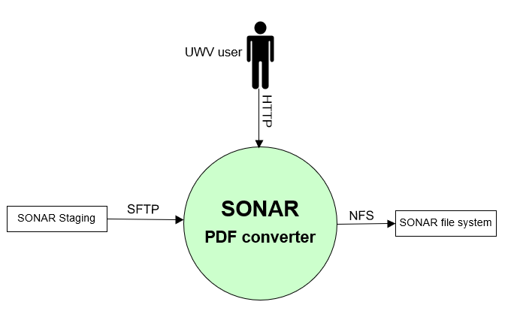

##### Entity UWV user

|  |  |
| --- | --- |
| **Description** | HTTP access to Sonar PDF converter |
| **Protocol and Port** | HTTP (80) |
| **DC (Datacenter) connection** | External |
| **Direction** | Inbound |
| **Direct connection** | Yes |
| **Security Controls** | Authorisation method or authentication method: Select (mandatory)  Use certificates: Select (mandatory)  Service account: Select (mandatory)  Other: <(only mention if applicable) other applicable security control related configuration>  From HLD: Not specified |
| **Number of users** | Not specified |
| **Number of transactions** | Not specified |
| **Frequency of transactions** | Not specified |
| **Volume of data in transit** | Not specified |

##### Entity SONAR Staging

|  |  |
| --- | --- |
| **Description** | Provide template |
| **Protocol and Port** | SFTP (22) |
| **DC (Datacenter) connection** | Internal |
| **Direction** | Inbound |
| **Direct connection** | Yes |
| **Security Controls** | Authorisation method or authentication method: Select (mandatory)  Use certificates: Select (mandatory)  Service account: Select (mandatory)  Other: <(only mention if applicable) other applicable security control related configuration>  From HLD: Not specified |
| **Number of users** | Not specified |
| **Number of transactions** | Not specified |
| **Frequency of transactions** | Not specified |
| **Volume of data in transit** | Not specified |

##### Entity SONAR file system

|  |  |
| --- | --- |
| **Description** | Access to SONAR file system |
| **Protocol and Port** | NFS (2049,111) |
| **DC (Datacenter) connection** | Internal |
| **Direction** | Outbound |
| **Direct connection** | Yes |
| **Security Controls** | Authorisation method or authentication method: Select (mandatory)  Use certificates: Select (mandatory)  Service account: Select (mandatory)  Other: <(only mention if applicable) other applicable security control related configuration>  From HLD: Not specified |
| **Number of users** | Not specified |
| **Number of transactions** | Not specified |
| **Frequency of transactions** | Not specified |
| **Volume of data in transit** | Not specified |

#### SONAR Staging

##### Entity UWV FB

|  |  |
| --- | --- |
| **Description** | SSH access to SONAR Staging (from UCRA) |
| **Protocol and Port** | 1. SSH (22) via UCRA  2. SFTP (22) |
| **DC (Datacenter) connection** | Internal |
| **Direction** | Inbound |
| **Direct connection** | 1. No  Via: SSH via UCRA  2. Yes |
| **Security Controls** | Authorisation method or authentication method: Select (mandatory)  Use certificates: Select (mandatory)  Service account: Select (mandatory)  Other: <(only mention if applicable) other applicable security control related configuration>  From HLD: Not specified |
| **Number of users** | Not specified |
| **Number of transactions** | Not specified |
| **Frequency of transactions** | Not specified |
| **Volume of data in transit** | Not specified |

##### Entity SONAR database

|  |  |
| --- | --- |
| **Description** | Reading templates from staging server, staging server is placed in the DXC Application Management from where is connects to Production, Acceptance and KATO |
| **Protocol and Port** | SFTP (22) |
| **DC (Datacenter) connection** | Internal |
| **Direction** | Outbound |
| **Direct connection** | Yes |
| **Security Controls** | Authorisation method or authentication method: Select (mandatory)  Use certificates: Select (mandatory)  Service account: Select (mandatory)  Other: <(only mention if applicable) other applicable security control related configuration>  From HLD: Not specified |
| **Number of users** | Not specified |
| **Number of transactions** | Not specified |
| **Frequency of transactions** | Not specified |
| **Volume of data in transit** | Not specified |

##### Entity SONAR PDF Converter

|  |  |
| --- | --- |
| **Description** | Reading templates from staging server, staging server is placed in the DXC Application Management from where is connects to Production, Acceptance and KATO |
| **Protocol and Port** | SFTP (22) |
| **DC (Datacenter) connection** | Internal |
| **Direction** | Outbound |
| **Direct connection** | Yes |
| **Security Controls** | Authorisation method or authentication method: Select (mandatory)  Use certificates: Select (mandatory)  Service account: Select (mandatory)  Other: <(only mention if applicable) other applicable security control related configuration>  From HLD: Not specified |
| **Number of users** | Not specified |
| **Number of transactions** | Not specified |
| **Frequency of transactions** | Not specified |
| **Volume of data in transit** | Not specified |

##### Entity OBI

|  |  |
| --- | --- |
| **Description** | Connection from the OBI ETL server to SONAR staging |
| **Protocol and Port** | SFTP (22) |
| **DC (Datacenter) connection** | Internal |
| **Direction** | Inbound |
| **Direct connection** | Yes |
| **Security Controls** | Authorisation method or authentication method: Select (mandatory)  Use certificates: Select (mandatory)  Service account: Select (mandatory)  Other: <(only mention if applicable) other applicable security control related configuration>  From HLD: Not specified |
| **Number of users** | Not specified |
| **Number of transactions** | Not specified |
| **Frequency of transactions** | Not specified |
| **Volume of data in transit** | Not specified |

#### SONAR IOD

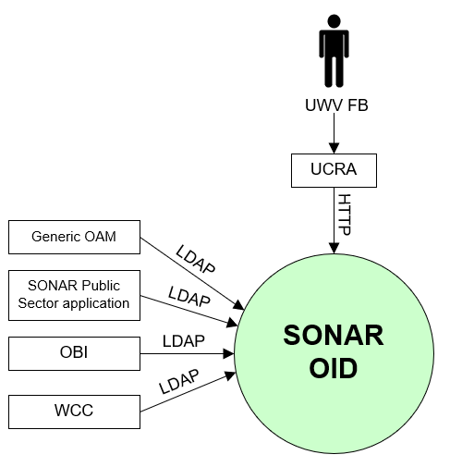

##### Entity UWV FB

|  |  |
| --- | --- |
| **Description** | UWV Functional Support |
| **Protocol and Port** | HTTP (80) |
| **DC (Datacenter) connection** | Internal |
| **Direction** | Inbound |
| **Direct connection** | No  Via: UCRA |
| **Security Controls** | Authorisation method or authentication method: Select (mandatory)  Use certificates: Select (mandatory)  Service account: Select (mandatory)  Other: <(only mention if applicable) other applicable security control related configuration>  From HLD: Not specified |
| **Number of users** | Less than 10 total assumed |
| **Number of transactions** | Not specified |
| **Frequency of transactions** | Not specified |
| **Volume of data in transit** | Low |

##### Entity WCC

|  |  |
| --- | --- |
| **Description** | SSO (Single Sign On) OID application, applications that share user single sign-on with SONAR are connecting read-only to the SONAR OID user store for their S2S (system to system) accounts. |
| **Protocol and Port** | LDAP (389, 3060) |
| **DC (Datacenter) connection** | Internal |
| **Direction** | Inbound |
| **Direct connection** | Yes |
| **Security Controls** | Authorisation method or authentication method: Select (mandatory)  Use certificates: Select (mandatory)  Service account: Select (mandatory)  Other: <(only mention if applicable) other applicable security control related configuration>  From HLD: Not specified |
| **Number of users** | Not specified |
| **Number of transactions** | Not specified |
| **Frequency of transactions** | Not specified |
| **Volume of data in transit** | Not specified |

##### Entity OBI

|  |  |
| --- | --- |
| **Description** | SSO (Single Sign On) OID application, applications that share user single sign-on with SONAR are connecting read-only to the SONAR OID user store for their S2S (system to system) accounts. |
| **Protocol and Port** | LDAP (389, 3060) |
| **DC (Datacenter) connection** | Internal |
| **Direction** | Inbound |
| **Direct connection** | Yes |
| **Security Controls** | Authorisation method or authentication method: Select (mandatory)  Use certificates: Select (mandatory)  Service account: Select (mandatory)  Other: <(only mention if applicable) other applicable security control related configuration>  From HLD: Not specified |
| **Number of users** | Not specified |
| **Number of transactions** | Not specified |
| **Frequency of transactions** | Not specified |
| **Volume of data in transit** | Not specified |

##### Entity SONAR Public Sector application

|  |  |
| --- | --- |
| **Description** | Access to config and status data |
| **Protocol and Port** | LDAP (389, 3060) |
| **DC (Datacenter) connection** | Internal |
| **Direction** | Inbound |
| **Direct connection** | Yes |
| **Security Controls** | Authorisation method or authentication method: Select (mandatory)  Use certificates: Select (mandatory)  Service account: Select (mandatory)  Other: <(only mention if applicable) other applicable security control related configuration>  From HLD: Not specified |
| **Number of users** | Not specified |
| **Number of transactions** | Not specified |
| **Frequency of transactions** | Not specified |
| **Volume of data in transit** | Not specified |

##### Entity Generic OAM

|  |  |
| --- | --- |
| **Description** | User authentication providing single sign-on for Sonar users using Generic OAM. OAM is connecting to the OID instance of Sonar |
| **Protocol and Port** | LDAP (389, 3060) |
| **DC (Datacenter) connection** | Internal |
| **Direction** | Inbound |
| **Direct connection** | Yes |
| **Security Controls** | Authorisation method or authentication method: RBAC (AD) (mandatory) Secure transport  Use certificates: Select (mandatory)  Service account: Select (mandatory)  Other: <(only mention if applicable) other applicable security control related configuration> |
| **Number of users** | 1 |
| **Number of transactions** | Not specified |
| **Frequency of transactions** | Not specified |
| **Volume of data in transit** | Low |

#### Stand-alone file server

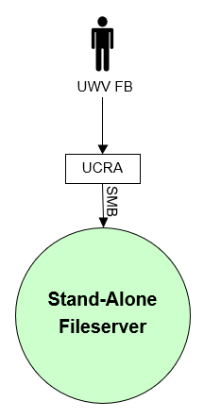

##### Entity UWV FB

|  |  |
| --- | --- |
| **Description** | UWV Functional Support, access to Word documents |
| **Protocol and Port** | SMB v3 (445) |
| **DC (Datacenter) connection** | Internal |
| **Direction** | Inbound |
| **Direct connection** | No  Via: UCRA |
| **Security Controls** | Authorisation method or authentication method: RBAC (AD) (mandatory) Secure transport  Use certificates: Select (mandatory)  Service account: Select (mandatory)  Other: <(only mention if applicable) other applicable security control related configuration> |
| **Number of users** | Less than 10 |
| **Number of transactions** | Not specified |
| **Frequency of transactions** | Not specified |
| **Volume of data in transit** | Low |

# Functional Requirements

* Siebel eBusiness App Integration (EAI) and Siebel Public Sector must be separated, each must have its own web servers and application servers
* In the Sonar (Production only) environment an additional Windows File server is required to host customer data (The data involved are SONAR documents which could not be migrated properly to EA). UWV Sonar FB must be able to access the data via a network share.

# Non-Functional Requirements

## Security & Compliance classifications

Repository used is: “2020 UWV-brede Risico Applicatie Lijst v1.0”

[BIV classificatie 2.0](https://samenwerken.sharepoint.uwv.nl/sites/DWU/ConcernICT/IBenP/CISO-Office/SiteAssets/SitePages/4.%25)

|  |  |
| --- | --- |
| **Application** | SONAR |
| **Owner** | WB |
| **Availability (Beschikbaarheid)** | 3(Kritiek) |
| **Integrity (Integriteit)** | 2(hoog) |
| **Confidentiality (Vertrouwelijkheid)** | 2+(Extra vertrouwelijk) |
| **Type of information /Data Classification** | Private information for customers or 3rd party |

### Applicable security and compliance frameworks

|  |  |  |
| --- | --- | --- |
| Security & Compliance Framework | Applicable | Comments |
| BIO | Yes (applicable) | If Not Applicable (Not compliant) please explain |
| AVG / GDPR | Yes (applicable) | Only select No if no personal data is handled. GPDR is mandatory in all other cases |
| DIGID | No (not applicable) |  |
| SUWI | No |  |
| Additional frameworks | Not applicable |  |

## System and Software requirements

### Private Cloud system

#### System (Operating system (OS))

| **Server(type)** | **Operating System** | **Version** |
| --- | --- | --- |
| <example: Database server 1> | <RHEL> | <8.5> |
|  |  |  |

#### System capacity forecast (volumetrics)

| **Server(type)** | **vCPU** | **RAM (GB)** | **Data Storage (GB)**  Data storage size for the OS is fixed |
| --- | --- | --- | --- |
| <example: Database server 1> |  |  |  |
|  |  |  |  |

#### Availability

|  |  |  |  |
| --- | --- | --- | --- |
| **Environment** | **Description** | **DXC Application Target**  (Availability (service hours) = SLA) | **Infra Target* (only for Application target 98%)**  (Availability (service hours) = SLA) |
| Production | SONAR OID  SONAR file system  SONAR database | 98% (5 x12 (Mo-Fr, 7-19h)) = TAB Basis | 99,8% (7x24) = Gold |
| Production | SONAR Public Sector  SONAR EAI  SONAR document / correspondence  SONAR Gateway  SONAR PDF converter  SONAR logical standby database | 98% (5 x12 (Mo-Fr, 7-19h)) = TAB Basis | 99,5% (7x24) = Silver |
| Production | Stand-alone file server  Staging server | 98% (5 x12 (Mo-Fr, 7-19h)) = TAB Basis | 98% (7x24) = Bronze |
| Acceptance | All Acceptance and Kanban servers | 98% (5 x12 (Mo-Fr, 7-19h)) = TAB Basis | 98% (7x24) = Bronze |

#### Storage replication

|  |  |
| --- | --- |
| **Environment** | **Storage Replication** |
| Production | Replicated storage |
| Acceptance | Replicated storage |

#### Scalability

| **Server(type)** | **Scalability type** | **Additional Comments** |
| --- | --- | --- |
| <example: server 1> | Kies een item. |  |
| <example: server 2> | Kies een item. |  |

In case of infra load balancer, specify requirements:

Load balancer infra requirements

|  |  |
| --- | --- |
| **Application Layer** | HTTP (L7) |
| **Application Port(s)** | 80 |
| **Algorithm** | Least Connections (default) |
| **Stickiness/Persistence** | None |
| **Health monitor type** | System-HTTP |

Please note: the default algorithm is: Least connections. Do not deviate from this, unless theres is a specific reason.

#### Software (Licenses)

| **Server(type)** | **Software product / component** | **Version** |
| --- | --- | --- |
| <example:Database server 1> | <Oracle Database server> | <19c> |
| <example:Database server 1> | <Oracle Active Data Guard> | <19c> |

#### System management

If there are no specific system management, then state: “not applicable”

#### Additional application related infra requirements

|  |  |
| --- | --- |
| **Requirements** | **Status** |
| Use STARTTLS option for UWV mail1 | No |
| Is Microsoft DTC used for inflight transactions2 | Not applicable |
| Mention other relevant requirements |  |

Please note:

1 UWV mail (The internal KPN mailrelay's for UWV (uwvmailrelay.voorzieningen.uwv.nl, prt 25) is equipped with the STARTTLS option.

This means that every application server can now send the SMTP messages encrypted if desired. STARTTLS is based on negotiation. TLS is not mandatory but is preferred. Mail clients that do not want or cannot use TLS can continue to send mail.  The TLS version used is TLS V1.2. To enable TLS, systems must be provided with Digicert's root and intermediate certificates. This is a public CA that appears in all common certificate stores.

2 In case SQL AOAG (Always On Availability Groups) is used, then MSDTC (Microsoft Distribuited Transaction Coordinator) needs to be configured as a cluster service)

#### DXC TAB requirements

|  |  |
| --- | --- |
| **Category** | **Description** |
| 1. Deployment method | other (specify)  Xldeploy is not applicable instead TAB deployment server (see HLD Werk.nl) is used  TAB NFS (see HLD Werk.nl) connections are required for applications that require shared storage (such as Weblogic) |
| 1. Deployment permissions |  |
| 1. Application Monitoring |  |
| 1. Other TAB applicable requirement | Not specified at this moment .  If applicable (for example sitescope application monitoring), the information must come from DXC TAB after KT sessions are completed and the required App info is available.  This will be documented in HLD 1.1 |

## Performance requirements

* The server sizing is based on the sizing before the transition. Performance tests after setting up the Acceptance environment should indicate whether the infrastructure must be up- or downscaled.
* The additional File server in Production is configured based on the current usage, no growth is expected.

## Security requirements

* SONAR end-users must be authenticated with Generic OAM (Generic OAM is configured to use Sonar OID as identity provider for Sonar).
* Only use SSL ciphers (certficates) that are supported by RUEI (applicable for SONAR and Generic OAM). Forward secrecy will not work for RUEI
* For the stand-alone File server, the following must be enabled:
  + File share auditing (Failure and Success)
  + Encryption for SMB (version 3) traffic
* UWV FB needs additional permissions on the Sonar DB, at least read / write

### System logging retention time

No specific system logging requirements are applicable

Detailed Standard Security requirements are documented in Appendix D

The standard system log retention: 1 year

Please specify if there is a deviation from standard, for example retention for: 5, 7 or 10 years.

otherwise mention “standard”

## Backup and Recovery

|  |  |  |
| --- | --- | --- |
|  | **Default** | **Deviation (when applicable)** |
| Backup | Select | Specify deviation (see instruction for backup standards) |
| Restore | no specific restore order | Specify restore order when applicable |
| Dependency | no dependencies | Specify dependency when applicable ( for example backup with the same time stamp is required to avoid data inconsistency) |

## Disaster Recovery

No specific disaster recovery requirements applicable.

# Appendix: Legenda Context Diagram

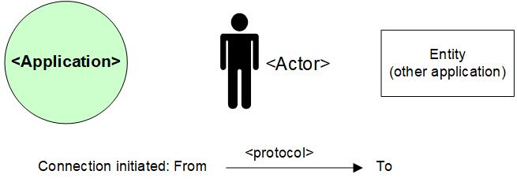

# Appendix: MCPaaS – Capacity allocation details

**EXAMPLE**

**Capacity allocation for <CompetentNL>**

To manage the resource allocation and assure the project uses only appropriate or agreed resources on the cluster, the quotas and limits to compute resources for the CompetentNL projects on the MCPaaS will be based on below details.

|  |  |  |  |  |  |  |
| --- | --- | --- | --- | --- | --- | --- |
| **Service (pod)** | **Mem Reservation** | **Mem Limit** | **CPU Reservation** | **CPU Limit** | **Scale - nr of containers (Development)** | **Scale - nr of containers (Test)** |
| CNL-Backend | 256M | 512M | 0,1 | 0,3 | 1 | 1 |
| CNL-Frontend | 128M | 256M | 0,1 | 0,5 | 1 | 1 |
| CNL-IAM | 256M | 512M | 0,1 | 0.5 | 1 | 1 |
| CNL-Dataloader | 256M | 512M | 0,1 | 0,2 | 1 | 1 |
| CNL ActiveMQ | 256M | 512M | 0,1 | 0,3 | 1 | 1 |
| CNL-Config-server | 128M | 256M | 0,1 | 0,2 | 1 | 1 |
| CNL-api | 256M | 512M | 0,1 | 0,5 | 1 | 1 |
| CNL-Synchronization | 128M | 256M | 0,1 | 0,3 | 1 | 1 |
| CNL-DB Management | 128M | 256M | 0,1 | 0,2 | 1 | 1 |
| CNL-Search | 1024M | 3072M | 0,1 | 1 | 1 | 1 |

*Total Required resource allocation*

*Note: Required resource allocation for Development and Test is an initial estimation. After initial tests on these environments resource allocation for all environments will be finalized and updated. Besides the resource allocation for Acceptance and Production are based on the experiences from Development and Test.*

|  |  |  |  |  |
| --- | --- | --- | --- | --- |
| **Size description** | **Development** | **Test** | **Acceptance** | **Production** |
| Mem minimum run | 2816M | 2816M | TBD | |
| Mem maximum run | 6656M | 6656M |
| CPU reservations | 1 | 1 |
| CPU reservations limit | 4 | 4 |